Terraform Final Task
1) Create VPC
2) Create Internet gateway
3) Create Custom Route Table
4) Create Subnet
5) Associate subnet with Route Table
6) Create Security Group to allow port 22.80,443
7) Create a network interface with an ip in the subnet that was created in step 4
8) Assign an elastic IP to the network interface created in step 7
9) Create Ubuntu server and install/enable apache2
Note:
1) Create single main.tf which will be created the above resources and do not hardcode the id's.
2) Configure s3 as backend and dynamo db locking for multi user execution.

Template Used to create given Infrastructure including S3 and DynamoDB.

Main.tf: - Template of all resources.
provider "aws" {
region = var.aws_region
}

# 1. Create VPC
resource "aws_vpc" "main" {
cidr_block = var.vpc_cidr
enable_dns_support = true
enable_dns_hostnames = true

tags = {
Name = "${var.project}-vpc"
}
}

# 2. Internet Gateway
resource "aws_internet_gateway" "igw" {
vpc_id = aws_vpc.main.id

tags = {
Name = "${var.project}-igw"
}
}

# 3. Route Table
resource "aws_route_table" "rt" {
vpc_id = aws_vpc.main.id

route {
cidr_block = "0.0.0.0/0"
gateway_id = aws_internet_gateway.igw.id
}

tags = {
Name = "${var.project}-rt"
}
}

# 4. Subnet
resource "aws_subnet" "subnet" {
vpc_id = aws_vpc.main.id
cidr_block = var.subnet_cidr
availability_zone = var.availability_zone
map_public_ip_on_launch = true

tags = {
Name = "${var.project}-subnet"
}
}

# 5. Associate Subnet with Route Table
resource "aws_route_table_association" "rt_assoc" {
subnet_id = aws_subnet.subnet.id
route_table_id = aws_route_table.rt.id
}

# 6. Security Group
resource "aws_security_group" "sg" {
name = "${var.project}-sg"
description = "Allow SSH, HTTP, HTTPS"
vpc_id = aws_vpc.main.id

ingress {
from_port = 22
to_port = 22
protocol = "tcp"
cidr_blocks = ["0.0.0.0/0"]
}

ingress {
from_port = 80
to_port = 80
protocol = "tcp"
cidr_blocks = ["0.0.0.0/0"]
}

ingress {
from_port = 443
to_port = 443
protocol = "tcp"
cidr_blocks = ["0.0.0.0/0"]
}

egress {
from_port = 0
to_port = 0
protocol = "-1"
cidr_blocks = ["0.0.0.0/0"]
}

tags = {
Name = "${var.project}-sg"
}
}

# 7. Network Interface
resource "aws_network_interface" "eni" {
subnet_id = aws_subnet.subnet.id
private_ips = [var.private_ip]
security_groups = [aws_security_group.sg.id]

tags = {
Name = "${var.project}-eni"
}
}

# 8. Elastic IP (deprecation fixed)
resource "aws_eip" "eip" {
domain = "vpc"
network_interface = aws_network_interface.eni.id
associate_with_private_ip = var.private_ip

tags = {
Name = "${var.project}-eip"
}
}

# 9. Ubuntu EC2 with Apache2
resource "aws_instance" "ubuntu" {
ami = var.ami_id
instance_type = var.instance_type
availability_zone = var.availability_zone

network_interface {
network_interface_id = aws_network_interface.eni.id
device_index = 0
}

user_data = <<-EOF
#!/bin/bash
sudo apt update -y
sudo apt install apache2 -y
sudo systemctl enable apache2
sudo systemctl start apache2
echo "<h1>Mubeen Terraform Apache Server</h1>" | sudo tee /var/www/html/index.html
EOF

tags = {
Name = "${var.project}-ubuntu"
}
}

# 10. S3 Bucket for Backend
resource "aws_s3_bucket" "tf_backend" {
bucket = var.s3_bucket_name

tags = {
Name = "${var.project}-backend"
}
}

resource "aws_s3_bucket_versioning" "tf_backend_versioning" {
bucket = aws_s3_bucket.tf_backend.id

versioning_configuration {
status = "Enabled"
}
}

resource "aws_s3_bucket_server_side_encryption_configuration" "tf_backend_encryption" {
bucket = aws_s3_bucket.tf_backend.id

rule {
apply_server_side_encryption_by_default {
sse_algorithm = "AES256"
}
}
}

# 11. DynamoDB Table for State Locking
resource "aws_dynamodb_table" "tf_lock_table" {
name = var.dynamodb_table_name
billing_mode = "PAY_PER_REQUEST"
hash_key = "LockID"

attribute {
name = "LockID"
type = "S"
}

tags = {
Name = "${var.project}-lock"
}
}

Variables.tf: Variables are used to avoid hardcoding.
variable "aws_region" {
default = "us-east-1"
}

variable "project" {
default = "mubeen-tf"
}

variable "vpc_cidr" {
default = "10.0.0.0/16"
}

variable "subnet_cidr" {
default = "10.0.1.0/24"
}

variable "availability_zone" {
default = "us-east-1a"
}

variable "private_ip" {
default = "10.0.1.50"
}

variable "ami_id" {
default = "ami-020cba7c55df1f615" # Ubuntu 22.04 LTS
}
variable "instance_type" {
default = "t2.micro"
}

variable "s3_bucket_name" {
default = "mubeen-tf-backend-bucket"
}

variable "dynamodb_table_name" {
default = "mubeen-tf-lock-table"
}

After adding the templates initialise, run command terraform init.
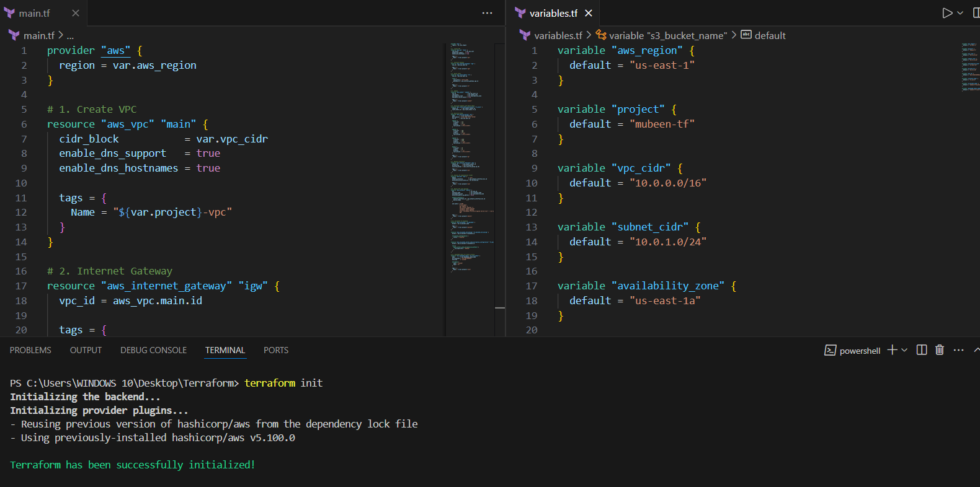

terraform apply to execute the templates.
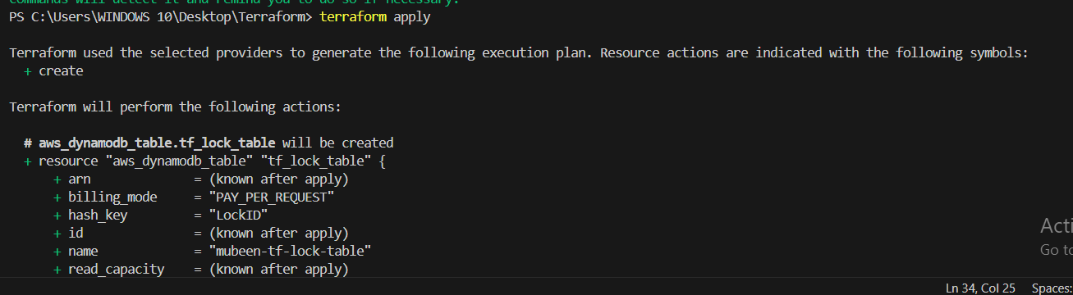

Verifying the infrastructure at console one by one.

1) Create VPC
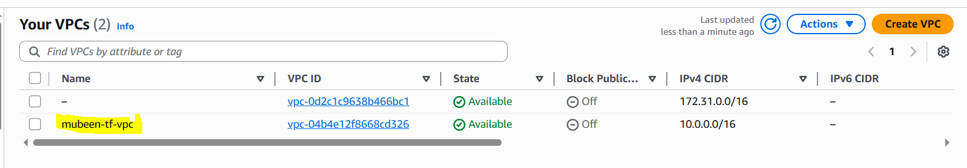

2) Create Internet gateway
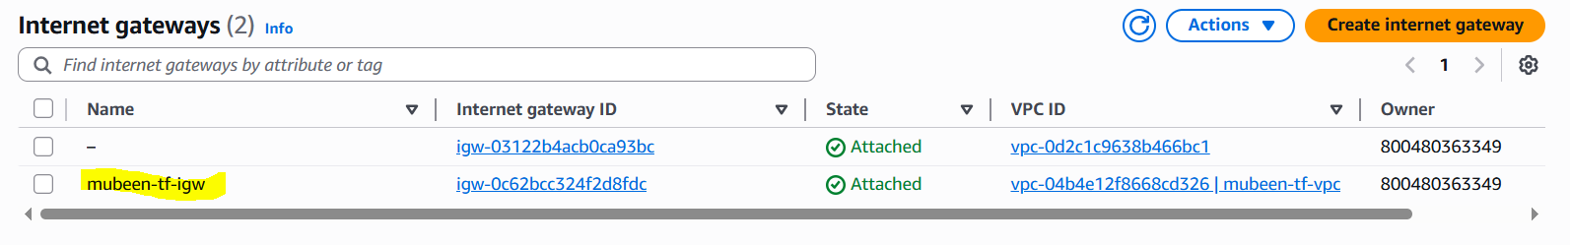

3) Create Custom Route Table
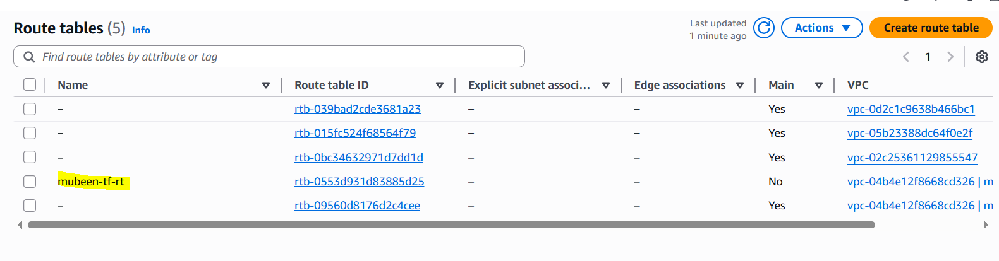

4) Create Subnet
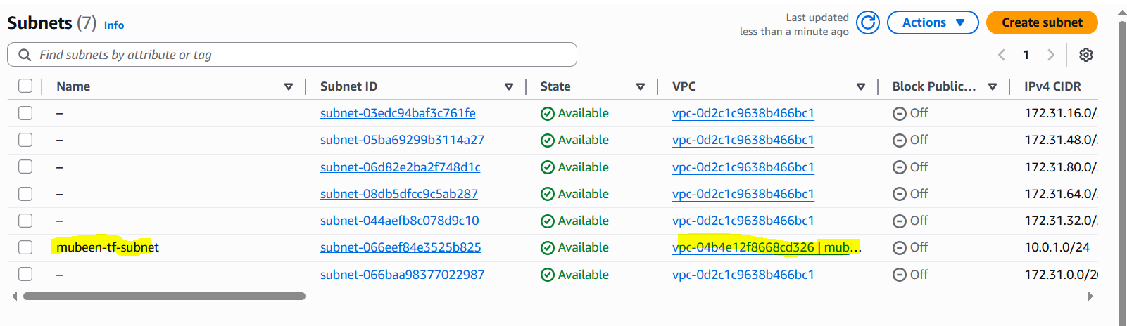

5) Associate subnet with Route Table
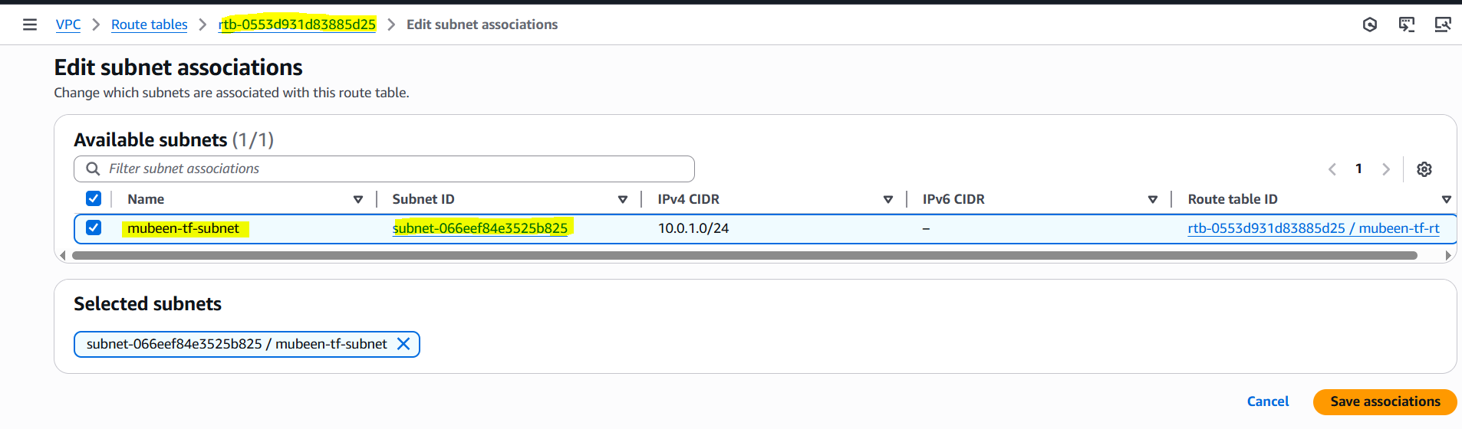6) Create Security Group to allow port 22.80,443
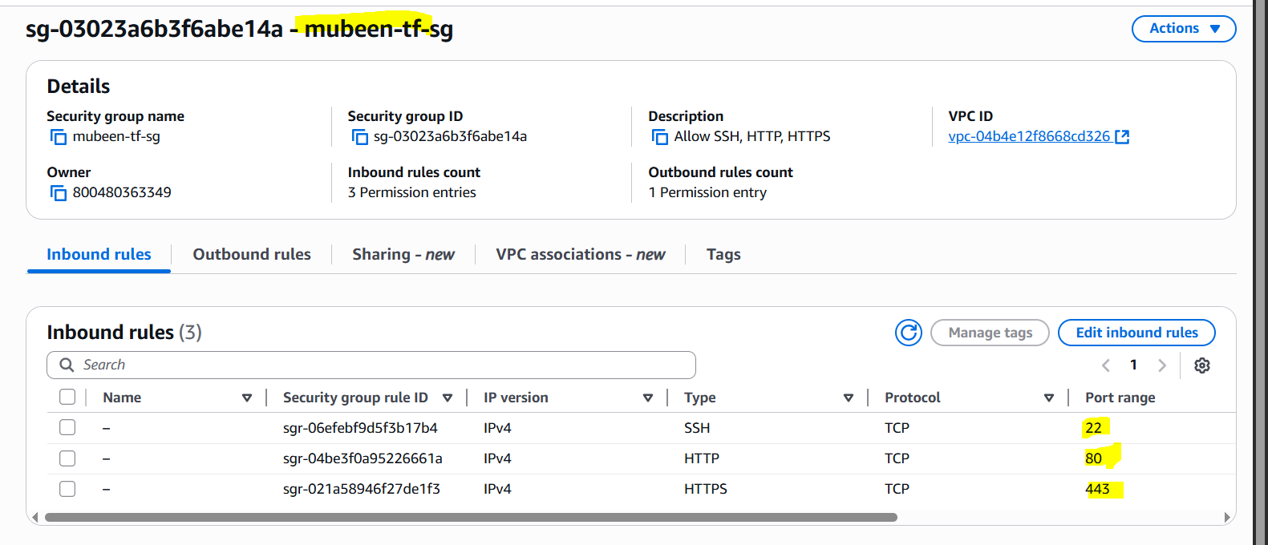

7) Create a network interface with an ip in the subnet that was created in step 4
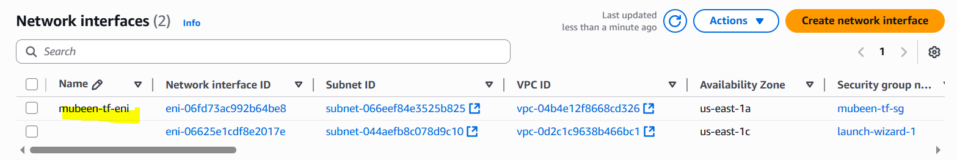

8) Assign an elastic IP to the network interface created in step 7
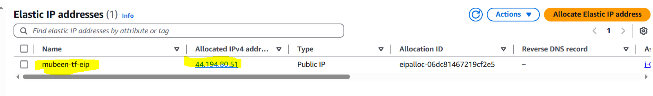

9) Create Ubuntu server and install/enable apache2
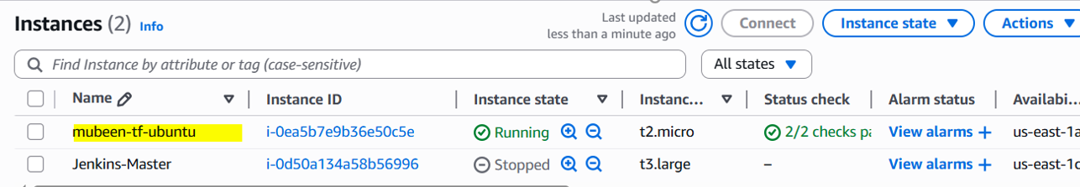

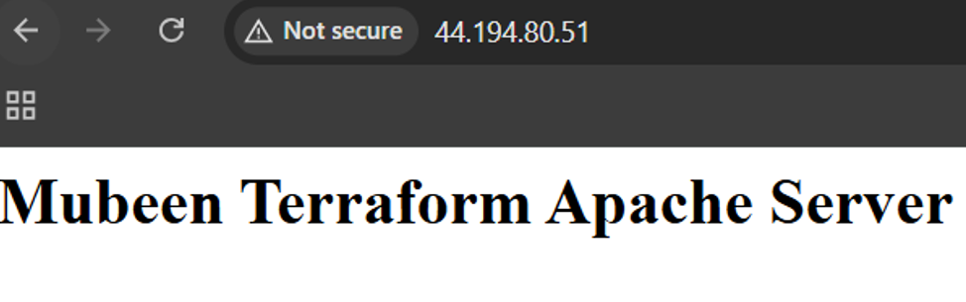

Verifying s3 & DynamoDB.
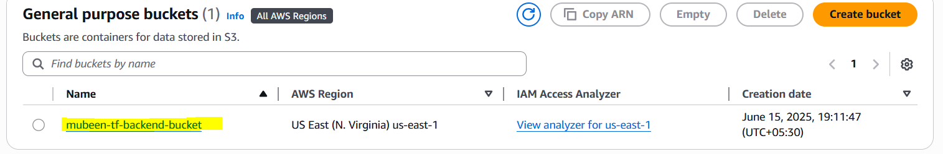
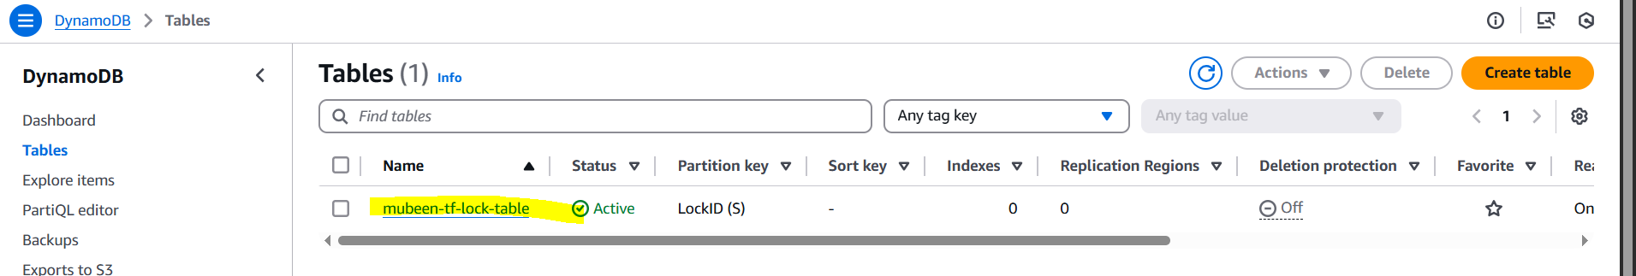

1) Create single main.tf which will be created the above resources and do not hardcode the id's.
Used variables.tf for this condition.
2) Configure s3 as backend and dynamo db locking for multi user execution.
We already created s3 bucket and DynamoDB, just need to configure backend and state lock.

Configuring template:
terraform {
backend "s3" {
bucket = "mubeen-tf-backend-bucket"
key = "terraform/state.tfstate"
region = "us-east-1"
dynamodb_table = "mubeen-tf-lock-table"
encrypt = true
}
}

Then terraform init,
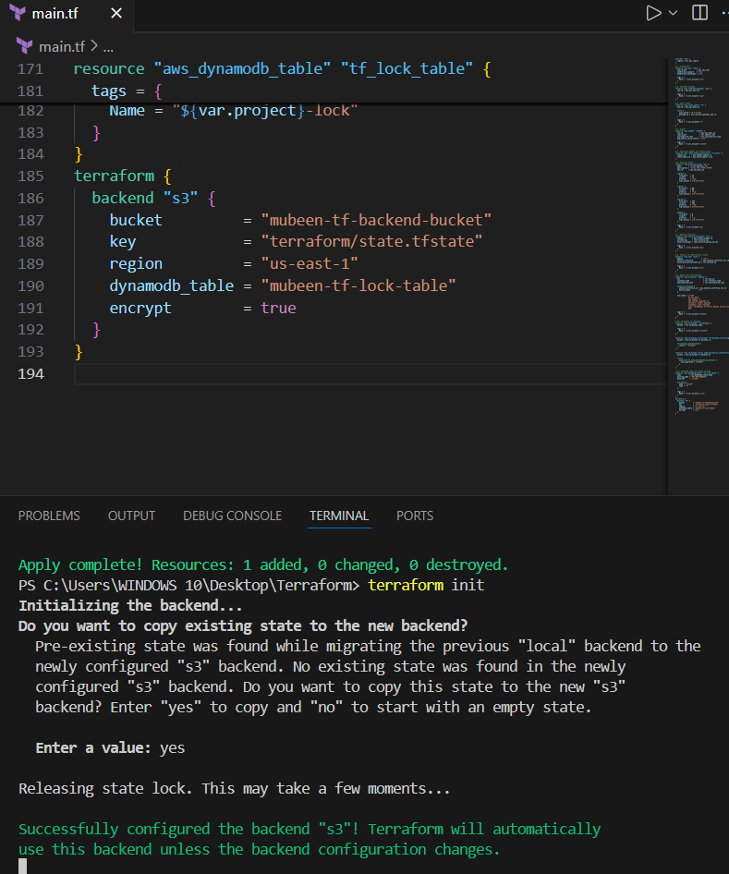
Verifying Backend:
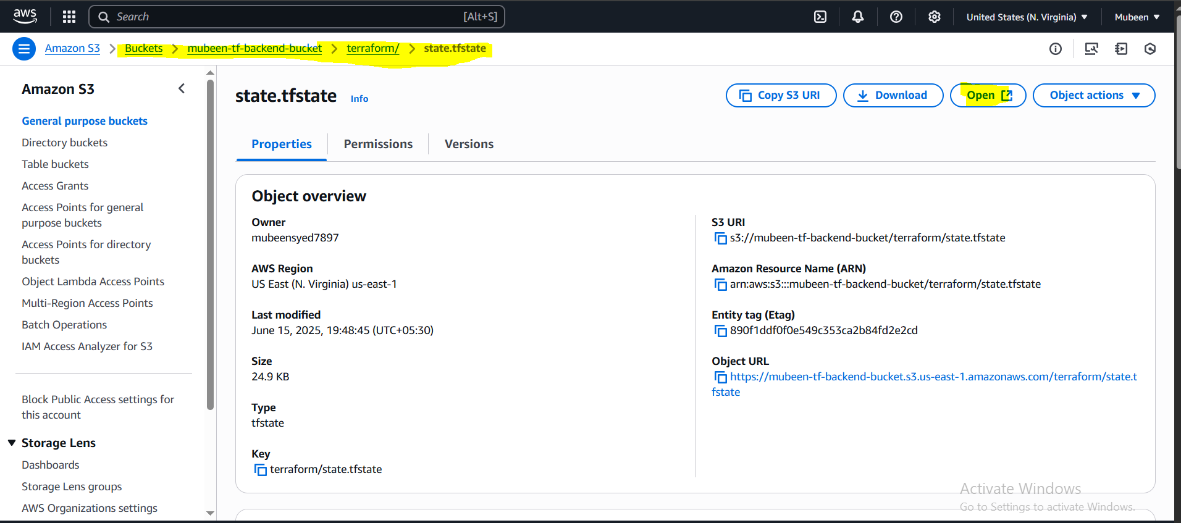
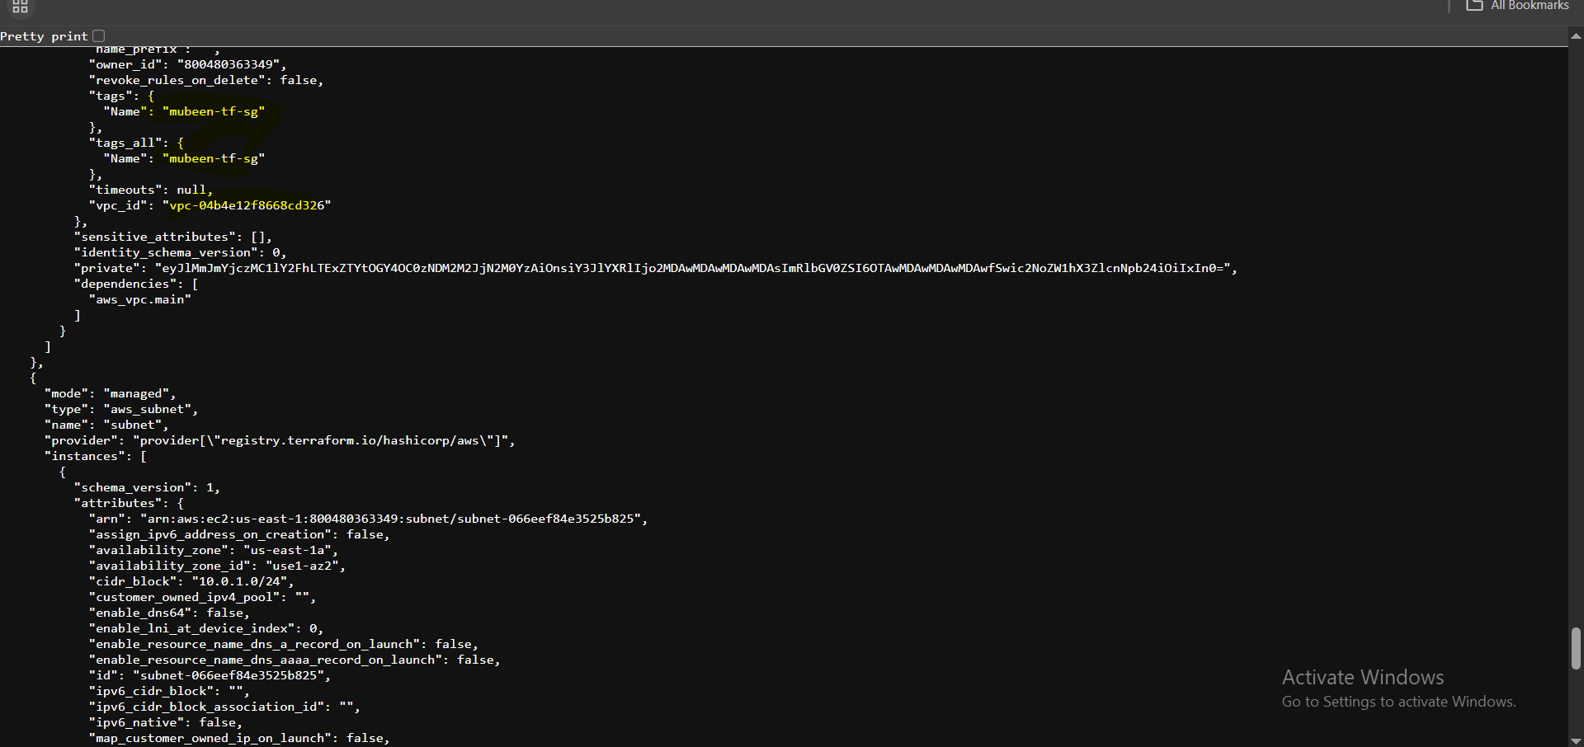

Verifying state lock:
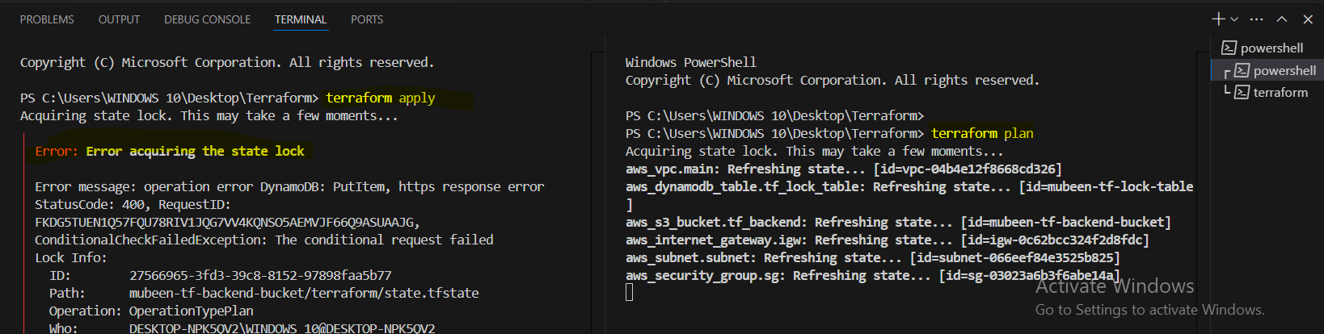

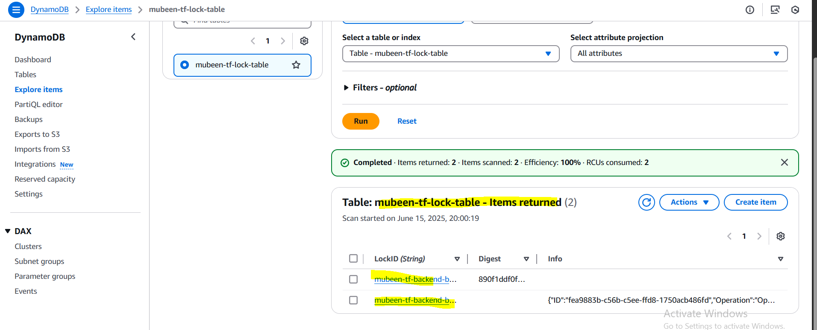
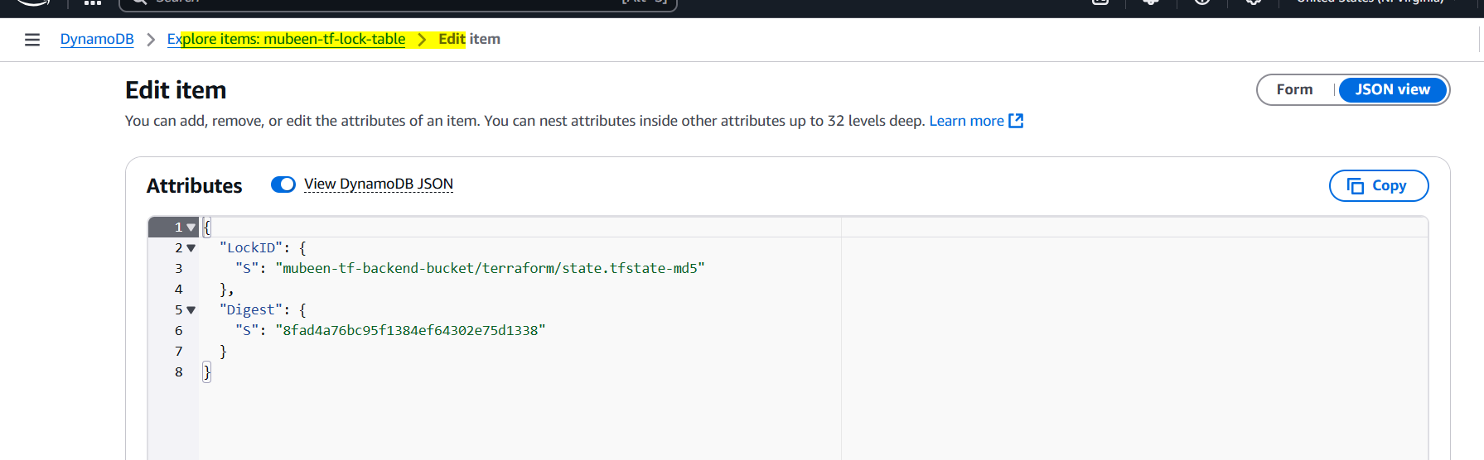

THE-END

